
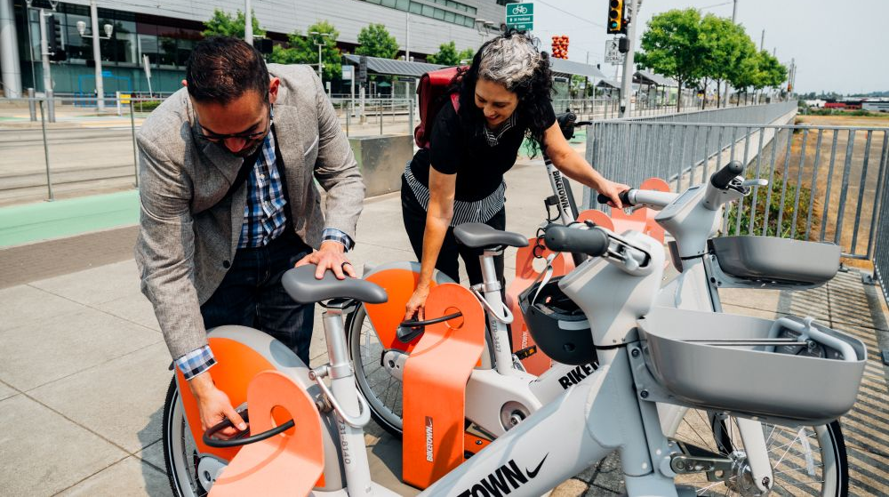








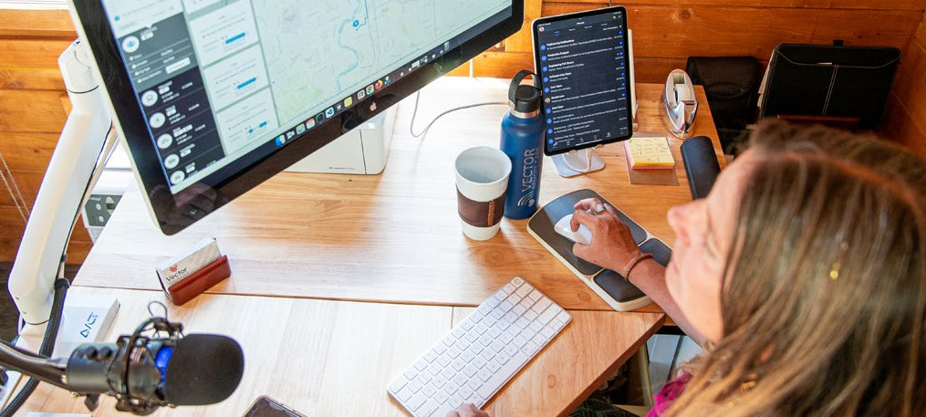
00
Access Employer Guides & Toolkits
Retain & Recruit
Improve commutes and work experience for better staff retention, plus attract talent by offering micromobility perks.
Solve First/Last Mile
Commute Problems
Make it easier for employees to reach worksites from transit hubs using bikes, scooters, shuttles, and car share.
Enhance Onsite Mobility
Equip employees, including commute options users, to get around campuses and off-site by providing fleet bike, scooters, and/or vehicles for use.
Improve Health
& Wellness
Active commuting delivers all kinds of employee health and wellness benefits.
Reduce Traffic
& Facility Costs
Decrease onsite vehicle traffic, while lowering parking demand to curb facility costs.
Boost Sustainability
Reduce air emissions and collective climate impacts to improve sustainability.
Micromobility broadly refers to short-distance travel, most often in urban areas, large campuses, and industrial parks. Ideal for “micro” trips, bicycles and scooters—whether human-powered, electric, owned, shared, or rented on-demand—have grown significantly in popularity. Micromobility can also include ride-hailing and car sharing services, shuttles, and onsite fleets of bikes, scooters, and vehicles.

For employees, micromobility can transform commutes and make daily business-related travel easier and less time-consuming. One of the biggest challenges in employee commuting is often the first- and last-mile—the gap between a starting point and nearby public transit—that may be too far to walk easily. Micromobility solutions can help solve these first- and last-mile challenges, while greatly expanding employee access to public transit.

As affordability and sustainability matter more than ever, micromobility—getting around over short distances—has become vital in how we collectively live, play, and work. From commuting to business-related travel, micromobility can help employees get around more efficiently, while reducing stress, time, and cost. For employers, micromobility can boost employee job satisfaction and retention, serve as an effective recruiting tool to attract talent, and reduce operational and parking-related expenses.

There’s been an evolution in micromobility innovation, options, tools, and services in recent years. Mobile apps now provide convenient, on-demand access to transportation 24/7. Power-assisted e-bikes and e-scooters make riding easier, while eliminating the “sweat factor.” Micromobility service providers have also grown in scale to offer enhanced and expanded options and cover larger service areas.
What is Micromobility?
MICROMOBILITY BENEFITS
Micromobility Solutions for Employees
Photo Credit: BIKETOWN, Portland
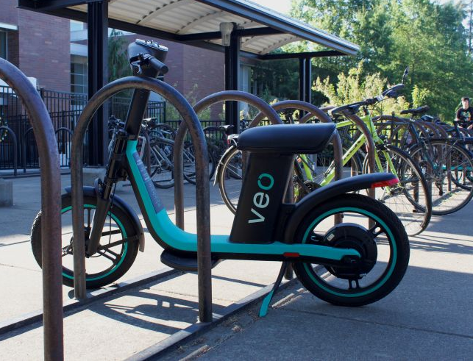

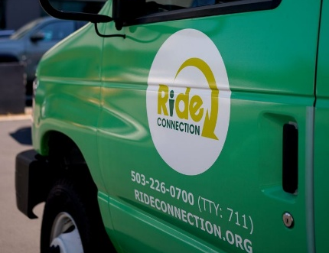
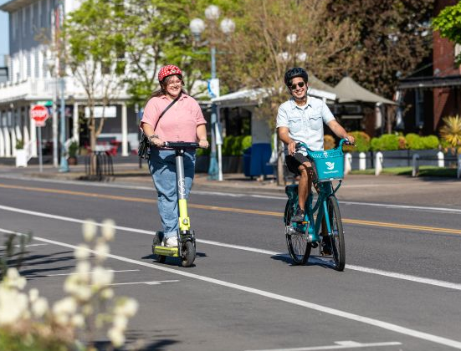
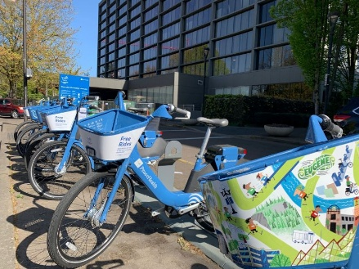
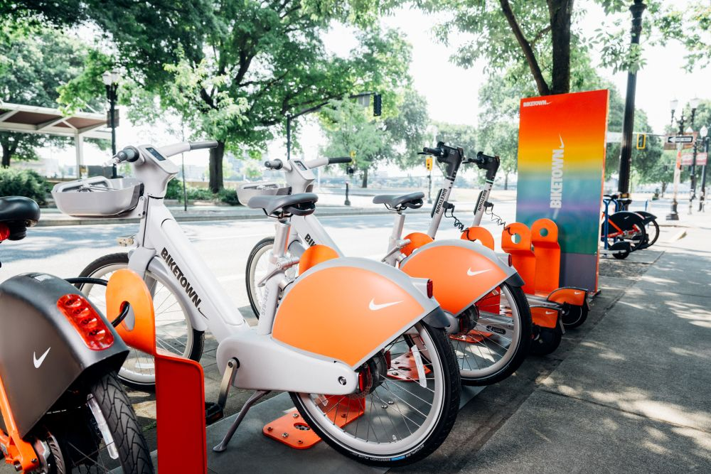
Ride-Hailing & Car Share
Ride-hailing and car share services give workers an on-demand transportation option from point-to-point 24/7. These services can be especially helpful when employees who use commute options need an emergency ride home. Some services offer business plans for employers to fully or partially subsidize ride costs for employees. Most urban areas across Oregon have ride-hailing and car share services.
Onsite Fleets
Providing shared bikes, scooters, and/or vehicles for employee use can make it easier and more efficient to travel across campuses and reach off-site destinations. Shared fleets can also help reduce onsite traffic congestion and parking demand by encouraging employees to use of commute options. Additionally, onsite fleets give employees greater flexibility to travel during the workday without relying on personal vehicles, address first- and last-mile commuting challenges, and make mid-day trips more convenient. A mixed fleet of transportation options can better accommodate a variety of employee travel needs. Shared fleets may be managed directly by employers or through independent providers that offer fleet management tools for easy reservation, tracking, and use.
Shuttles
Shuttle services, operated by transit agencies, employers, and non-profit organizations, help connect neighborhoods and workplaces to fixed route transit systems, addressing common first- and last-mile commuting challenges. Shuttles typically operate during peak commute hours and are scheduled to align with transit arrival and departure times. In areas with limited transit—particularly industrial districts—shuttle services can help increase employee transit use, while supporting recruitment and retention efforts.

Scooters & E-Scooter Share
A new generation of scooters and e-scooters is another option for getting around urban areas. Many scooters are foldable, making them easy to bring on buses, store in workplaces, or keep under desks. Other scooter models can be securely locked up for storage. Employers can support employee scooter use by providing secure storage areas and charging stations for employees. Public 24/7 e-scooter rental is currently available in Portland and employers can choose to subsidize rental costs for employees.

Bikes & Bike Share
Biking is ideal for short trips, helping riders avoid traffic congestion and parking challenges while providing health, cost-savings, and environmental benefits. Urban commuters can also take advantage of bike share services, which offer on-demand access to bikes that can be picked up and returned at designated stations or locked up at approved locations. Bikeshare bikes are especially useful for connecting to transit hubs, making appointments, and running errands. Rentals can be purchased for single rides or through memberships, which employers can help subsidize. Public 24/7 bike share services are currently available in Bend, Eugene/Springfield, and Portland.
For employee program support & resources at no cost, contact:
 Employers@GetThereOregon.org |  971-202-9758
Visit GetThereOregon.org
Micromobility Solutions
Photo Credit: BIKETOWN, Portland
Photo Credit: Comet Robinson/OSU, Corvallis
Photo Credit: Lyft Urban Solutions, Portland
Photo Credit: Ride Connection, Portland Metro
Photo Credit: Jeremy Fenske, Eugene
Photo Credit: Melanie Griffin/Eugene Cascades & Coast

