](https://www.istockphoto.com/photo/friends-fasten-seat-belt-before-leaving-for-vacations-gm679527882-124538065)

**Employee Benefits**

**Saves money** on commute costs

Improves **job satisfaction** by reducing stress from traffic, long commutes, & parking hassles

Frees up **time to relax** & **recharge** during the commute

Boosts **mental health & productivity**

Reduces personal carbon emissions

►

►

►

►

►

**Carpool Programs 101**

**Equip employees to carpool for better job satisfaction, retention, & more!**

Employees are **spending more money and time on commuting** as costs and distances traveled for work have increased. Bad commutes not only **hurt job satisfaction, retention, and productivity**, but can **discourage job candidates from applying to join your team**.

For employers looking to improve commutes, especially those in industrial districts and non-urban areas with limited transportation options and 24/7 shifts, **carpooling offers employees a practical commute solution that nets all kinds of benefits**.

Here’s how to build successful employee carpool programs, using **free tools and support services** from Get There Oregon and our partners.

**Business Benefits**

Increases **staff retention** by improving work experience & job satisfaction

Serves as a recruiting tool to **attract talent**, including from farther away

Boosts **employee engagement,** **performance, & productivity**

Encourages **employee on-time arrival**

Decreases **parking demand & costs**

Reduces traffic for **better freight & service delivery**

Improves **sustainability** by reducing your organization’s carbon footprint

►

►

►

►

►

►

**Free Support Services & Tools**

►

**Promotions Support**

Download **ready-made and customizable employee materials** promoting carpooling and using Get There Connect in our [**Commute Solutions Toolkit**](https://getthereoregon.org/commute-solutions-toolkit/).

**Consultation & Planning**

Get expert help creating a **turnkey and cost-effective employee carpool program**.

**Carpool Matching Support**

Match employees into carpools using **Oregon’s free online** [**Get There Connect**](https://getthereoregon.org/wp-content/uploads/2024/03/Make-Commutes-Better-with-Get-There-Connect_Employer-Guide_FINAL.pdf) **tool**. For workers with limited digital access, carpool match cards are available.

[**Access employer guides & toolkits**](https://getthereoregon.org/for-employers/guides-reports/)

­

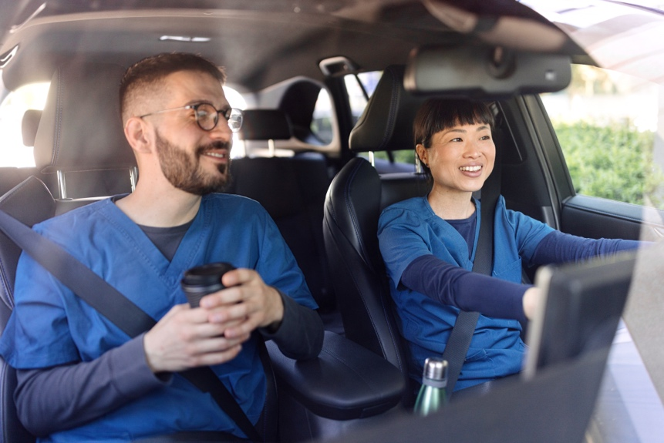

**Successful carpool program strategies**

**Match employees into carpools**

**Get the word out**

**Promote carpooling, rideshare tools, and perks/incentives** to your employees (turnkey materials can be downloaded in our [Commute Solutions Toolkit](https://getthereoregon.org/commute-solutions-toolkit/))

►

**Involve employee champions**, such as supervisors and green teams

**Hold lunch-n-learns and benefits fairs**—our local partners can assist you

►

►

**Provide perks & incentives**

Offerfree or reduced-rate **preferred onsite parking** or a **paid parking stipend**

►

Extend **emergency ride home options**(like taxi rides)

**Create a plan**

**Set up your carpool program**, covering business goals, employee carpool matching and coordination strategies, perks and incentives, and promotions

►

**Involve leadership and key departments**, such as HR, communications, environmental health and safety, facilities, and sustainability

**Tie in organizational initiatives,** such as HR benefits, health and wellness, sustainability, and new employee onboarding

►

►

**Help employees match up into carpools,** using tools like [**Get There Connect**](https://getthereoregon.org/wp-content/uploads/2024/03/Make-Commutes-Better-with-Get-There-Connect_Employer-Guide_FINAL.pdf)

►

**Post carpool match cards** in breakrooms for employees with limited digital access

►

**Involve scheduling and shift managers** to facilitate carpool matching

►



**Assist with carpool coordination**

**Provide employees with tips for setting up carpools** (visit the ‘For Commuters’ section on [GetThereOregon.org](https://getthereoregon.org/))

►

**Hold challenges & offer rewards**

**Organize challenges** to encourage employees to carpool

►

**Offer rewards** for logging carpool trips in Get There Connect to promote ongoing use

Take advantage of **statewide initiatives and local rewards programs**

►

►

►

**We’re here to help!**

For employee program and Get There Connect support:

✉ Employers@GetThereOregon.org | ☎ 971-202-9758

**Visit** [**GetThereOregon.org**](https://getthereoregon.org/)