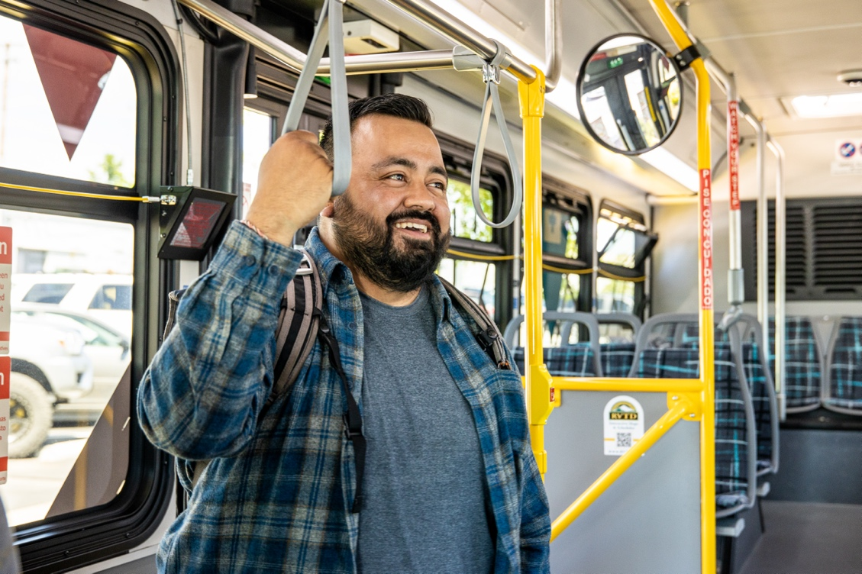

**Employee Benefits**

**Saves money** on commute costs

Provides **pre-tax savings** on up to $300 per month for transit expenses

Improves **job satisfaction** by reducing commute pain from traffic, long-haul commute, & parking hassles

Nets **time savings** to destress & recharge during the commute

Boosts **mental health & productivity**

Reduces personal carbon emissions

►

►

►

►

►

**Better Commutes**

**Transit Solutions**

**Equip employees to use transit for better retention, recruitment, & more!**

Today, the commute experience ranks highly among workers, impacting retention and recruitment alike. Yet, commutes have gotten worse due to longer distances traveled, traffic delays, and skyrocketing costs. Equipping employees to use transit can improve commutes and job satisfaction (especially when requiring more time in the office), while netting many business benefits.

Read on about why employers should prioritize improving employee commutes and how transit can benefit your employees and operations. Plus, access free services and tools from Get There Oregon and partners to help your employees commute using transit.

►

**Business Benefits**

Increases **staff retention** by improving job satisfaction

Serves as a recruiting tool to **attract talent**, including from farther away

Gains **payroll tax savings** by offering employees pre-tax transit benefits

Boosts **employee engagement,** **performance, & productivity**

Decreases **parking demand & costs**

Reduces traffic for **better freight & service delivery**

Improves **sustainability** by reducing your organization’s carbon footprint

►

►

►

►

►

**Why Do Employee Commutes Matter?**

**Improving Commutes Serves Business Needs**

Unlocking better employee commutes **serves many business needs**—retaining and recruiting talent, increasing productivity, cutting costs, improving sustainability, and more!

**Commute Distances Are Longer**

More workers now **commute from farther away**, adding to commute costs and time spent on the road.

**Commute Costs Have Risen**

Commute costs—fuel, vehicle maintenance, insurance, parking, and more—add up. US workers today spend about **19% of their annual income** on commuting.

►

►

­

[**Access employer guides & toolkits**](https://getthereoregon.org/for-employers/guides-reports/)

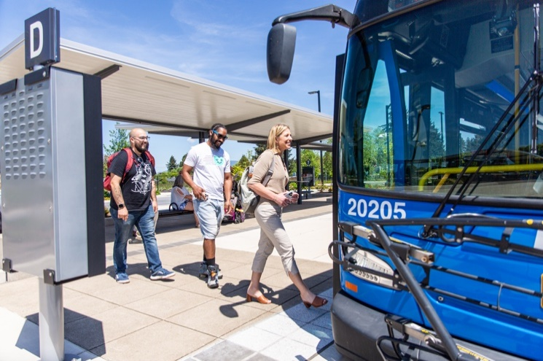

**FREE! Employer Services & Tools**

Get There Oregon and local partners offer **free services and tools** that can connect your employees to transit services.

**Consultation & Planning**

**Program Support**—get help building a turnkey employee commute program that supports transit use and other commute options.

►

**Employee Surveys**—access resources and support services to conduct employee commute surveys and gain useful insights on how to make commutes better.

**Metrics** **Tracking**—evaluate and grow your employee commute program using metrics tracking tools, plus get analysis support.

►

►

**Employee Support Services**

**Transit Trip Planning**—equip employees to plan commute trips on transit using Oregon’s [Get There Connect](https://getthereoregon.org/wp-content/uploads/2024/03/Make-Commutes-Better-with-Get-There-Connect_Employer-Guide_FINAL.pdf) tool and your local transit provider’s website or mobile app.

**Discounted Passes**—transit providers offer group pass programs for employes to extend discounted passes to employees.

**Emergency** **Ride Home**—many transit providers offer programs to help commuters using transit to get home in case of an emergency.

**Benefits & Rewards**—offer free or discounted transit passes and take advantage of local employee rewards programs.

►

►

►

►

**Set Up A Pre-Tax Commuter Benefit for Tax Savings**

**Reduce your payroll taxes, while enabling employees to save money on their taxes by setting up a pre-tax commuter fringe benefit. Employees can set aside up to $300 per month to cover transit expenses for pre-tax savings. Employers can save about by about 7.5% in payroll taxes on the amount employees set aside. Get help by emailing us at Employers@GetThereOregon.org.**

**Promotions & Outreach**

**Employee Materials**—access ready-made and tailorable employee materials promoting transit using Oregon’s online [Commute Solutions Toolkit](https://getthereoregon.org/commute-solutions-toolkit/).

**Brown** **Bags & Benefits Fairs**—local partners can provide onsite personalized employee commute planning.

►

►

**Employee Surveys**

**Consultation & Planning**

=

**Need Help?**

**Resources.  
Support.  
Solutions.**

►

►

**Promotions & Outreach**

►



Contact:

✉ Employers@GetThereOregon.org

☎ 971-202-9758

**Visit** [**GetThereOregon.org**](https://getthereoregon.org/)