Employer Guides

Get There Oregon’s employer guides provide strategies, tips, and insights on taking your employee commute and work experience to the next level:

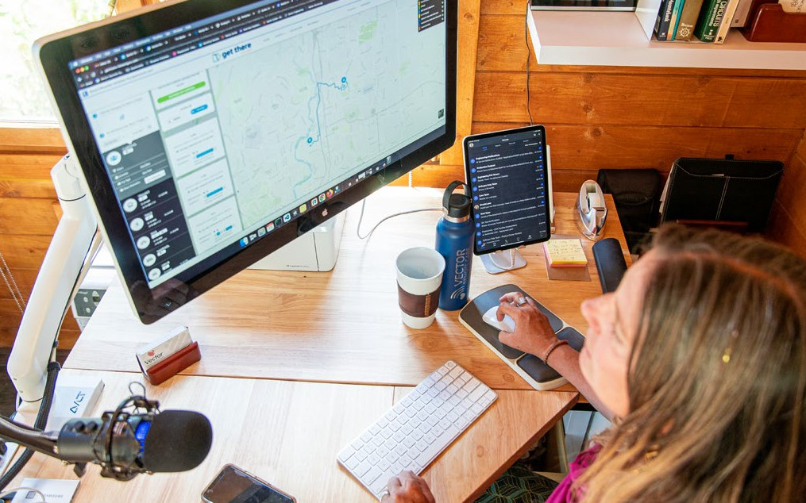
Commute Solutions Toolkit

Improve commutes & work experience for a thriving workforce
Employee commutes and work experience play big roles in job satisfaction, retention and recruitment, productivity, and more! Connect your employees to more affordable, active, and sustainable commute options using Oregon’s online Commute Solutions Toolkit. Plus, leverage free resources, tools, and support services from Get There Oregon and partners to improve employee commutes and help your workforce thrive and grow.

Toolkit Features

Easy to Access
Oregon’s Commute Solutions Toolkit is accessible online with free ready-to-use and customizable content at GetThereOregon.org/CST.

Promote Commute Options & Tools
Access employee materials and digital content covering all types of commute options—carpooling, vanpooling, transit, biking, remote work, and compressed work. Plus, get details and materials about local services and Get There Connect, Oregon’s commute planning and rewards tool.

Co-Brand & Customize Content
Posters, flyers, display slides, and digital content can be
co-branded and customized without graphic design software. Materials are print-ready and digital content can be used in employee communications and Intranet sites.
- How Commute Solutions Serve Business Needs
- Employer Resources Guide
- Make Commutes Better with Get There Connect—FREE

- Employee Commuter Survey Solutions Tips & Tools

- Equip Employees to Carpool Using Free Tools & Services

- Bring Your Workforce A Smarter Way to Commute with Vanpooling

- Boost Employee Health & Wellness with Bike Commuting

- Improve Commutes & Flexibility with Compressed Work

- Improve Sustainability with Greener Commute Options

Access more employer guides and toolkits here.

Employee Commute Support Tips

Offer Information & Resources
  - Provide information about commute options, services, and the commuter benefits you offer using the Commute Solutions Toolkit.
  - Equip employees with commute planning resources and tools like Get There Connect.
  - Help match employees into carpools and vanpools.
  - Post transit service and route information and offer discounted employee bus passes.
  - Connect employees with information on bike routes, skills, services, and maintenance.

Use Get There Connect FREE!
  - Equip employees to find and use commute options, join or start carpools and vanpools, and more.
  - Take advantage of statewide challenges and local rewards programs as added motivators for your employees.
  - Set up an employer network with custom URL and QR code for employees to join to track metrics, conduct surveys, offer internal rewards, and more.

Provide Perks & Rewards
  - Offer financial or prize rewards for using commute options as added incentives.
  - Extend credits for purchasing bikes and equipment and bus passes.
  - Provide on-site amenities for bike commuters like covered secure parking and repair tools.
  - Offer premium parking for carpoolers and vanpoolers.

Resources. Support.
Solutions.
Need Help?
Consultation & Planning Employee Surveys
Promotions & Outreach Support
Contact:
✉ Employers@GetThereOregon.org
☎ 971-202-9758

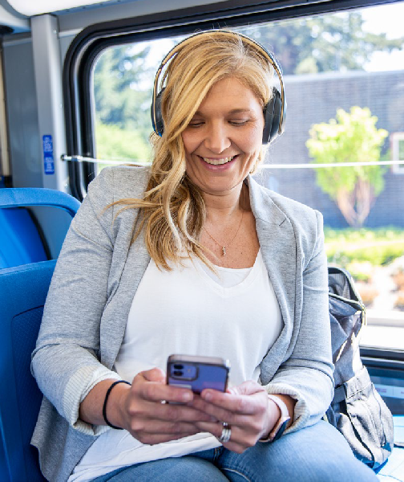
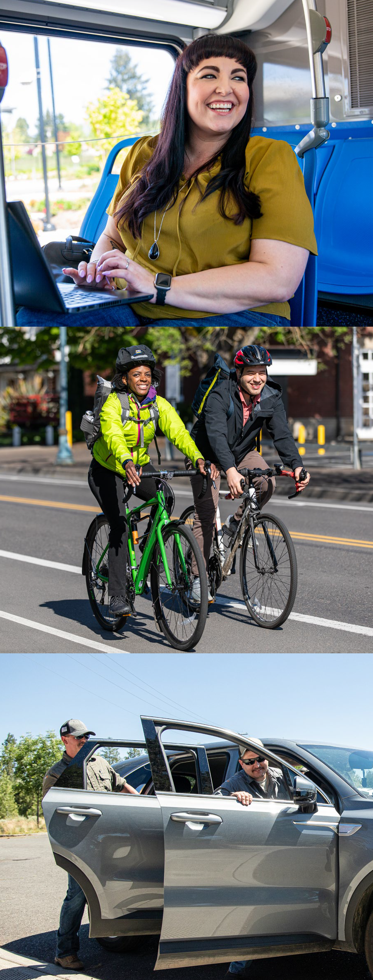
Visit GetThereOregon.org

