**Make Commutes Better**

**with Get There Connect FREE!**

**Equip your workforce & organization to thrive!**

Employee commutes and work experience play big roles today in job satisfaction, retention and recruitment, productivity, and more. Yet, **commutes have gotten worse due to longer distances, traffic delays, and skyrocketing costs.**

Make commutes and work experience better **using Get There Oregon’s *free* online Get There Connect tool** that connects your employees with more affordable, healthy, and sustainable commute options, while serving critical business needs.



**Your Employees Can:**

**Find** and **compare** commute options

**Join** or **start** carpools and vanpools

**Explore** bike routes and **find** biking partners

**Track stats** like money saved, calories burned, and reduced CO2

Enter **challenges** and earn **rewards**

►

►

►

►

►

**Your Organization Can:**

**Retain** and **recruit** staff by creating a supportive work environment

Increase **job satisfaction**, **employee engagement**, and **productivity**

Boost **employee health and wellness**

**Improve sustainability** by reducing environmental impacts

►

►

►

►

**How Does Get There Connect Work?**

Get There Connect is a **free online commute planning, ridematching, metrics tracking, and rewards tool** accessible via computer or mobile device.

**Getting Started is Easy:**

There’s **no set up required**—employees can sign up at [GetThereOregon.org](https://getthereoregon.org/)

Optional **free employer networks** with custom URLs and QR codes can be set up for employees to join and use that gives access to more tool features

**Technical support** and **ready-to-use employee materials** are available

►

►

Anyone who **lives and/or works in Oregon** can use Get There Connect. **English** and **Spanish** languages are currently supported.

►

Users **sign up at** [**GetThereOregon.org**](https://getthereoregon.org/)and can **join dedicated employer networks. Free technical support** is available to assist users and employers in using Get There Connect.

**Visit** [**GetThereOregon.org**](http://GetThereOregon.org/)

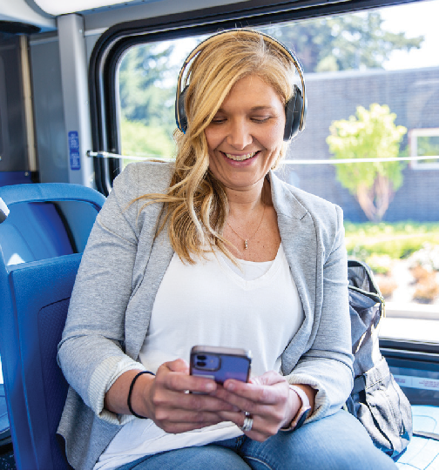

**FREE! Get There Connect Features**

**Employee Commute Planning**

Equip employees to explore commute options by accessing transit and biking routes, matching up into carpools and vanpools, finding park and rides, and more.

**Ridematching Support**

Help employees connect with others to join and start carpools and vanpools. Commute with Enterprise offers vanpool setup and vehicle rental services.

**Employee Surveys**

Conduct commuter surveys among your employee users, including as required by Oregon’s ECO Rule in the Portland metro area.

**Custom Employer Networks**

Free employer networks can be set up with custom URLs and QR codes for employee use to track organizational metrics, offer internal rewards and incentives, and hold challenges.

**Challenges & Rewards**

Take advantage of statewide challenges and local rewards programs (as available) as added motivators and incentives for your employees to use commute options.

**Track Metrics & Run Reports**

Gain workforce insights and track organizational metrics like employee commute options use, vehicle miles and CO2 reduced, money saved, and calories burned.

**Support Services**

**Roll Out & Network Set Up**

Rolling out Get There Connect doesn’t require any set up—employees can sign up and use the tool, and we can provide technical support. Free employer networks can be set up that give access to more tool features.

**Training & Webinars**

**Technical Support**

Get There Oregon and local partners can provide technical support on using Get There Connect. Information about tool features and how-to instructions can be accessed online.

**Promotions Support**

Ready-to-use employee materials that can be co-branded and customized are available in our online Commute Solutions Toolkit. Plus, Get There Oregon partners can provide commute planning onsite and at resource fairs.

Get There Oregon provides regular trainings and webinars on using Get There Connect. Past recordings can be accessed online. One-on- one trainings are also available.

**Resources. Support.**

**Solutions.**

**Need Help?**

For Get There Connect and employee program support:

 [Employers@GetThereOregon.org](mailto:Employers@GetThereOregon.org)  971-202-9758