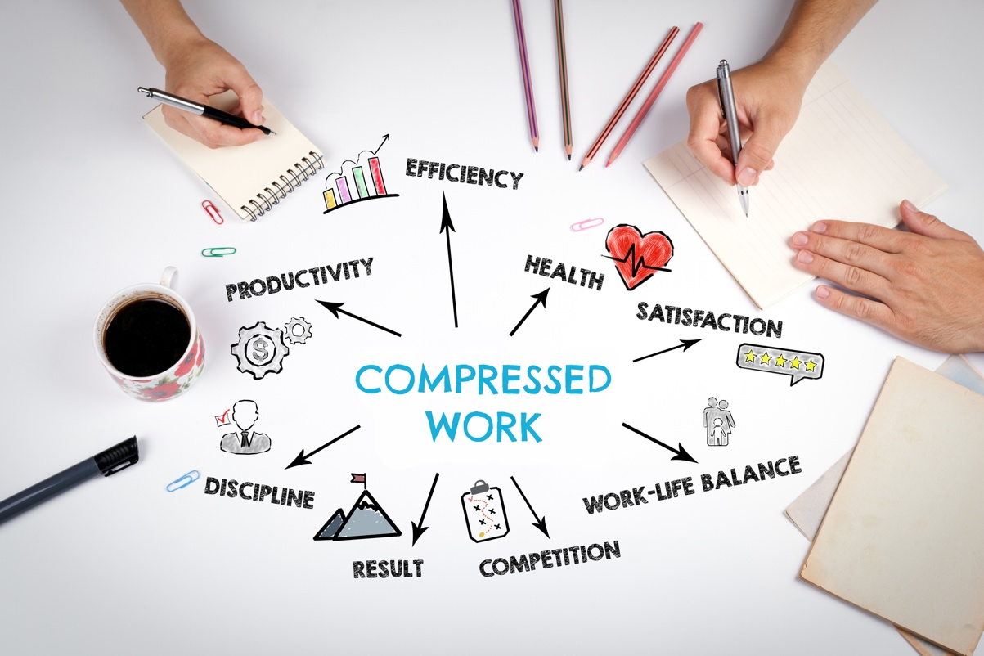



**Compressed Work Benefits**

**Boost Work Experience**

**& Productivity**

Reducing commute trips saves employees money and time, while easing financial strain, stress, and fatigue.

Giving employees work flexibility enables them to get personal errands and tasks done, which boosts their work-life balance.

Reducing commute strain and stress increases job satisfaction, morale, and productivity.





**Cut Commute**

**Costs & Strain**

**Improve commutes & flexibility with compressed work**



**Increase**

**Work-Life Balance**

Once an idea that provoked some skepticism, compressed work is gaining traction across the private and public sector for a wide range of job types. While remote and hybrid work has helped ease time-consuming and costly employee commutes, most workers must otherwise commute to worksites to get their work done. Compressed work provides an alternative for onsite employees that can reduce commute trips to ease financial strain and stress, while providing flexibility for better work-life balance.

Here’s a guide on how to set up compressed work at worksites—a flexible work scheduling approach benefiting employees and employers alike.







**What is compressed work?**

**Improve**

**Sustainability**

Eliminating commute trips to worksites reduces individual and organization CO2 emissions and other environmental impacts.

* **Four-Day Workweek**: Employees work four longer days, typically ten hours each, and have a three-day weekend.
* **3/12 Workweek**: Employees work three 12-hour days a week typically due to 24-hour staffing needs.
* **9/80 Schedule**: Employees work nine-hour days for nine days within two weeks with every other Friday off.

**Flextime**: Employees have the flexibility to choose their daily work hours within certain limits.

Compressed work is an alternative scheduling approach in which employees work a traditional workweek, generally 35 to 40 hours, in fewer than five days. There are many types of compressed work schedules that can be suited to different operations and job functions, including:

* **Four-Day Workweek**: Employees work four longer days, typically ten hours each, and have a three-day weekend.
* **3/12 Workweek**: Employees work three 12-hour days a week typically due to 24-hour staffing needs.
* **9/80 Schedule**: Employees work nine-hour days for nine days within two weeks with every other Friday off.
* **Flextime**: Employees have the flexibility to choose their daily work hours within certain limits.



**Retain & Recruit**

**Employees**

Creating a supportive work environment helps retain staff and attract new talent.

­

For support and access to resources and tools at no cost, contact:

 Employers@GetThereOregon.org |  971-202-9758

**Visit GetThereOregon.org**



**Tips for Implementing Compressed Work**



**Formalize Policies & Procedures**

Create a written set of policies and procedures to govern your compressed work program. Involve your organization’s accounting department in establishing policies for payroll, vacation pay, overtime, absences, and other issues.

**Determine Work Schedule Options**

Select the compressed work schedule(s) that best aligns with your operations and applicable job functions. Be mindful of team and departmental schedules so that worksites are adequately covered at all times.

**Assess Feasibility**

Evaluate whether compressed work is a viable option for your organization. Explore factors including workload and task manageability, team compatibility, operations and customer/client needs, and employee health and wellbeing.

**Check Labor Laws & Contracts**

Local laws and regulations may come into play, including employment and overtime pay laws. Review your organization’s labor contracts to determine whether they allow for compressed work.

**Make Commutes Better with Commute Options**



Connect your employees commuting onsite to more affordable, active, and sustainable commute options to improve work experience and enable your workforce to thrive!

**Bike Commuting**

**Carpooling**

**Vanpooling**



**Transit**





**Rollout Program**

Trial your compress work program in one department or worksite to start. Hold employee orientation meetings and provide information via worksite materials, Intranet sites, and email. Account for lessons learned and expand the program across your organization.



**Resources. Support. Solutions.**



Access free employer resources, support services, and tools to improve commutes.

Use Oregon’s free Get There Connect commute

planning, ridematching, metrics, and rewards tool.

Leverage challenges and local rewards programs as added motivators for employees.

Gain workforce insights, HR and operations strategies, and employee program tips.





For support and access to resources and tools at no cost, contact:

 Employers@GetThereOregon.org |  971-202-9758

**Visit GetThereOregon.org**