**Serve business needs by improving employee commutes**

Commuting is costing workers a lot more in money and time as costs have gone up and average distances traveled for work are longer. Bad commutes today are top reasons for costly employee attrition and hiring headwinds, lower morale, and reduced productivity.

Employers offering employees commute options support and benefits can serve a broad range of critical business needs. Unlock better commutes by equipping your employees to use commute options, including carpooling, vanpooling, biking, walking, working remotely, and using compressed schedules by starting a Commute Trip Reduction (CTR) program.

CTR programs usually include a mix of employee resources, services, onsite support, and benefits tailored to individual worksites. Read on about the benefits of starting a CTR program and get insights on effective setup strategies that can take your employee commute and work experience to the next level, while helping serve business needs.

**Employer Benefits**



Boost employee engagement, job satisfaction, and productivity

Attract and retain talent

Improve employee health and wellness

Reduce parking costs

Improve sustainability by reducing CO2 emissions and air pollution

Reduce traffic congestion

Gain tax savings













**Employee Benefits**

Save money on gas and vehicle maintenance

Boost health and wellness

Reduce stress from traffic and parking

Enjoy more free time

Socialize more with friends and colleagues

Reduce CO2 emissions and air pollution

Improve quality of life



**Why start a CTR program?**

Employers typically start CTR programs to help meet business goals, provide benefits for employees, and, in some cases, adhere to a CTR rule that applies to the organization. While some states have CTR rules effective statewide, Oregon’s Employee Commute Options rules, also called ECO, currently affects employers with 100 or more employees in the Portland Metro region. Whether affected by a CTR rule or not, many employers start CTR programs because of the benefits provided both to the organization and their employees.













For support and access to resources and tools at no cost, contact:

 [info@GetThereOregon.org](mailto:info@GetThereOregon.org) |  971-202-9758

Visit **GetThereOregon.org**

**Who runs CTR programs?**

Whether it's a dedicated staff member or someone with additional job responsibilities, an Employee Transportation Coordinator (ETC) often runs CTR programs within an organization or individual worksite. ETC responsibilities are part of a team member’s job function, such as within human resources, environmental, health and safety, or environmental and sustainability teams. These responsibilities often do not require an organization to hire additional staff. Employers with sizeable workforces may be best served by assigning duties to dedicated staff. Many employers often have someone in the role on a regular, full-time basis.

**How does a CTR work?**

The most successful CTR programs include a mix of employee resources, services, and benefits tailored to individual worksites. CTR program elements work together to meet the business needs and provide the employee benefits desired at a particular workplace. Common program elements include:

**EMPLOYEE COMMUTER RESOURCES AND SERVICES:**

* Commute options information and materials
* New employee welcome packets
* Carpool, vanpool, or bikepool matching assistance
* Commute route planning assistance
* Telework or flexible work schedules
* Midday transportation options (such as an emergency ride home service, employee car share, or bike share program)
* Secure bike parking and other amenities
* Preferential parking for carpools and vanpools

**TRANSPORTATION OPTIONS BENEFITS:**

* Employer-subsidized transit pass
* Commuter pre-tax benefits program
* Rewards and incentives
* Parking cash-out (cash incentives for employees who don't use on-site parking)
* Employer-sponsored vanpool

**EVENTS AND CAMPAIGNS:**

* Oregon Get There Challenge
* Bike to Work Day/Bike Month activities
* Transportation fairs
* Bike tune-up days

**RECOGNITION:**

* Employee recognition program
* Apply for external workplace recognition

**CTR program activities include:**

* Evaluating employee transportation habits, needs, and interests
* Providing employees with commute options information and support services (such as carpool and vanpool matching), while encouraging use
* Working with local Transportation Options providers to promote local programs and employee benefits (such as discounted transit passes)
* Identifying and implementing on-site infrastructure to support and encourage employee commute options use (such  
  as dedicated carpool parking and secure bike lockers)
* Administering benefits or incentive  
  programs and tracking metrics to demonstrate the impact

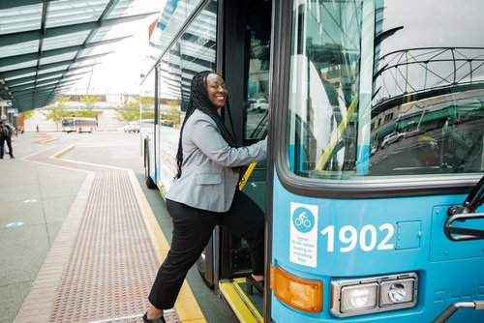

**How do I start or grow a CTR program?**

Get There Oregon and partners are ready to help you take your employee commute experience to the next level with free resources and tools. Get started by emailing us at [**info@GetThereOregon.org**](mailto:info@GetThereOregon.org) or call 971-202-9758.

Plus, visit [**GetThereOregon.org**](https://getthereoregon.org) and navigate to “For Employers” on the main menu to access the Employee Transportation Coordinator Toolkit for additional guidance on starting a CTR program.

For support and access to resources and tools at no cost, contact:

 [info@GetThereOregon.org](mailto:info@GetThereOregon.org) |  971-202-9758

Visit **GetThereOregon.org**