**Boost sustainability, health & affordability with greener  
commute options for your employees!**

Sustainability is a big concern for businesses and governments today. Consumer preferences for more sustainable products and services are on the rise. More employees, particularly millennials and gen z, prefer jobs with environmentally minded, socially responsible companies. There’s been a steady increase in adopting more sustainable lifestyles, too, and public concern about environmental issues and policies have grown.

Addressing transportation, including the commute, as a key part of sustainability offers substantial environmental gains and benefits. Drive alone commuting significantly adds to harmful air emissions and pollution, while contributing to both individual and organizational carbon footprints. By encouraging greener commute options, businesses and governments can reduce a sizable portion of their transportation-related emissions and impacts.

Lead the way in sustainability for a better today and tomorrow by empowering your employees to use greener commute options. Tap into free resources, tools, and support services available from Get There Oregon and our network of partners.

**Sustainable, healthy & affordable**

**commute options to meet**

**your employees’ needs**

**Carpool & Vanpool**

On-site employees can share the ride and the cost by carpooling

or vanpooling, especially when transit options and bike routes are limited.



**Transit**

Commuting by bus and rail enables employees to save money and get the time back they’d otherwise spend driving.

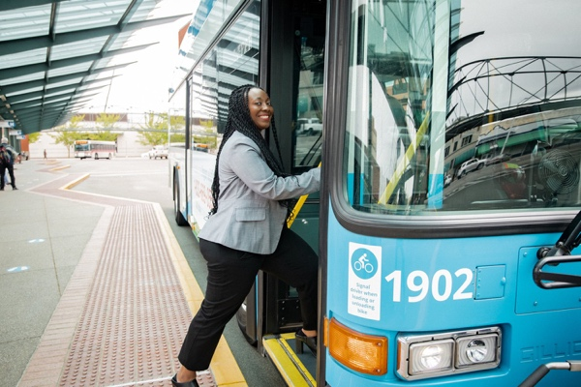

V

**Support Services & Tools**



**Bike & Walk**

Bicycling and walking offer

a wide range of health and wellness and financial benefits.

Get support creating a **turnkey and cost-effective employee program** from Get There Oregon and our network of partners.



Tap into Oregon’s free tool Get There Connect to **help employees with commute planning and matching up into carpools and/or vanpools** (see reverse/below).



**Remote Work**

Working remotely eliminates commute trips and costs, while saving time and giving greater work-life balance.



Promote sustainable commute options and support services to employees—**Get There Oregon and partners can provide employee materials and support**.

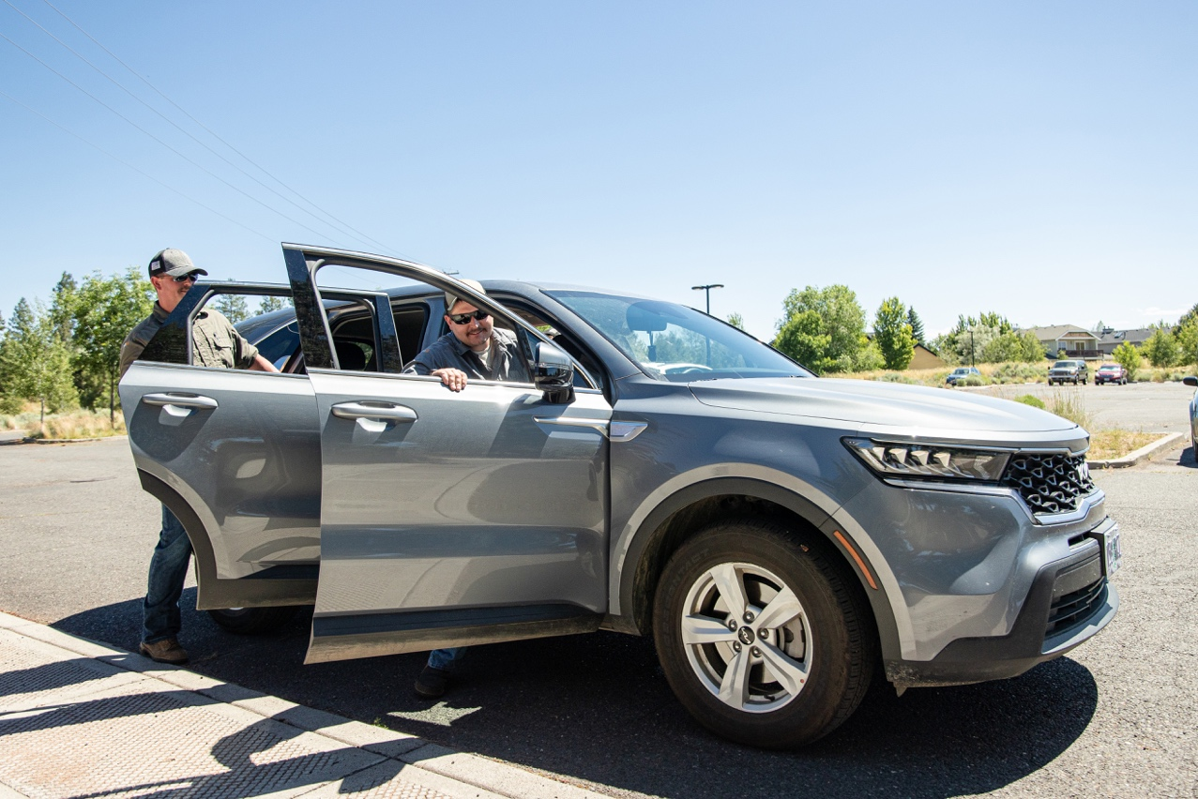

**Program Strategies & Tips**

Here are some strategies and tips for supporting employee use

of sustainable commute options:

* Provide commute planning and carpool and vanpool matching support on-site or by using Oregon’s free online tool Get There Connect
* Hold resource fairs at worksites to promote sustainable commute options benefits and services-our network of partners can help
* Form an employee green team to champion sustainable commute options
* Post transit route information

and tap into discounted bulk transit pass programs to help reduce employee costs

* Offer on-site amenities to promote bicycling like bike parking and personal lockers
* Connect employees with vanpool rental and maintenance services from Commute with Enterprise
* Set up remote work arrangements to reduce commute trips

**Tap Into Get There Connect****—FREE!**



**Set up a custom employer network**

Free employer networks can be set up in Get There Connect with custom URLs and QR codes for employee use and to track organizational metrics.

**What is Get There Connect?**

Get There Connect is Oregon’s free commute trip planning tool that can match employees up into carpools and vanpools, track metrics, and more.

**How do you access Get There Connect?**

Get There Connect is accessible via computer and mobile devices.

**Match up employees to share the ride**

Employees can use Get There Connect to match up with others living nearby and set up carpools and vanpools with each other.

**Track metrics and run reports**

Track and report on organizational metrics like vehicle miles and CO2 reduced.

**Manage rewards and incentives**

Get There Connect can be used to manage internal rewards and incentives. Payroll integration is available for a fee.



**Resources.  
Support. Solutions.**

Access employee programs, including

challenges and rewards.

Gain workforce insights, HR and operations strategies, and employee program tips.

Tap into Oregon’s free Get There Connect trip

planning, ridematching, metrics, and rewards tool

that offers employer networks for employees.

**Visit GetThereOregon.org**