**Visit GetThereOregon.org**

**Improve Sustainability**

Sharing rides reduces individual and organization CO2 emissions and environmental impacts.

**Save on Parking Costs**

Reduce on-site parking demand through employee carpooling and save money otherwise spent on expensive facility upgrades.

**Reduce Parking Demand**

Cutting back on the volume of vehicles at worksites reduces parking needs and congestion issues.

**Boost Work Experience & Morale**

Making employee commutes better improves job satisfaction and morale, while boosting productivity.

**Retain & Recruit Employees**

Reducing employee commute costs and improving commutes through carpooling can boost retention. Plus, building a supportive work environment can attract job candidates to join your team.

**CARPOOLING BENEFITS**

Get support putting together a **turnkey and cost-effective employee carpool program** from Get There Oregon and local partners.

Match employees into carpools using **Oregon’s free online tool Get There Connect**. For workers with limited digital access, carpool match cards are available to post up at worksites.

Promote carpooling among your employees and help them match up into carpools. Get There and partners can provide **employee materials and program support**.

**Empower employees to carpool for better job satisfaction, retention & more!**

Among the key factors impacting employee job satisfaction today, the commute is at the top of the list. Not withstanding the COVID crisis, employee commutes have steadily gotten longer not only due to growing traffic congestion, but farther distances traveled for work. Skyrocketing fuel costs and inflation are taking more out of employee paychecks, too.

* **More workers are commuting from father away** due, in part, to the lack of affordable housing.
* Average **commuting costs** were **up 34% to nearly $3,000** in 2022.
* **Daily commute times** for U.S. workers on average are **up to an hour long (55 minutes)**.

Shared commute solutions like carpooling give employers a competitive edge to retain and attract employees, especially on-site shift workers that can’t use transit or other options.

Empower employees to carpool using free ridematching tools and support services from Get There Oregon and partners—here’s how!

**SUPPORT TOOLS & SERVICES**

**Better Commutes**

**Carpooling Solutions**

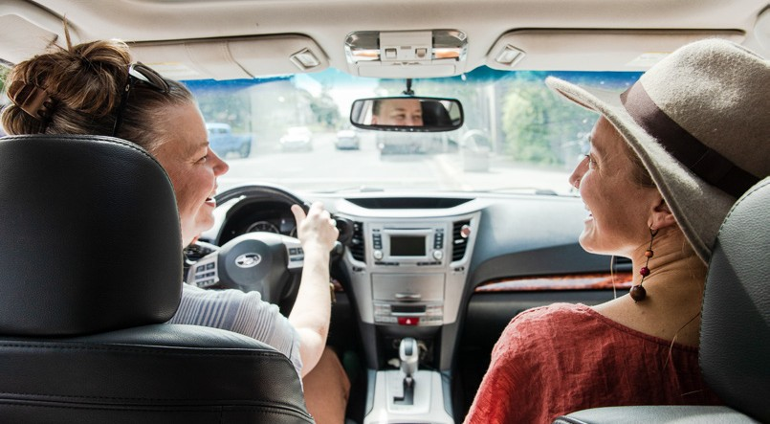

**employer forum**

**For Get There Connect support and help getting started:**

 [**info@GetThereOregon.org**](mailto:info@GetThereOregon.org) **971-202-9758**



Access employee programs, including challenges and rewards.

Tap into Oregon’s free Get There Connect trip planning, ridematching, metrics, and rewards tool that offers employer networks for employees.

Gain workforce insights, HR and operations strategies, and employee program tips.

**Manage internal rewards and incentives**

Get There Connect can be used to manage internal rewards and incentives. Payroll integration is available for a fee.

**Set up a custom employer network**

Free employer networks can be set up in Get There Connect with custom URLs and QR codes for employee use and to track organizational metrics.

**Track metrics and run reports**

Track and report on organizational metrics like carpool trips logged and CO2 reduced.

**Match up employees into carpools**

Employees can use Get There Connect to match with others living nearby and set up carpools with each other.

**How do you access Get There Connect?**

Get There Connect is accessible via computer and mobile devices.

**TAP INTO GET THERE CONNECT**

**What is Get There Connect?**

Get There Connect is Oregon’s free commute trip planning tool that can match employees up into carpools and vanpools, track metrics, and more.

* **Create a plan covering tools and services** that’ll be used and how you’ll **encourage carpooling among your employees**.
* Get different departments like HR and communications and employee supervisors involved in **planning and employee outreach**.
* **Tie in organizational initiatives**, such as wellness and
* benefits, sustainability, and facilities management programs.
* **Use rideshare matching tools like Get There Connect** to help employees connect with one another and carpool together.
* **Post carpool match cards in breakrooms** for those with limited digital access.
* **Tap into local Emergency Ride Home programs**.
* **Offer premium parking and other incentives** to carpoolers.

**EMPLOYEE CARPOOL PROGRAM TIPS**

Here are some strategies and tips to start up and grow an employee carpool program at your worksite:

**Visit GetThereOregon.org**

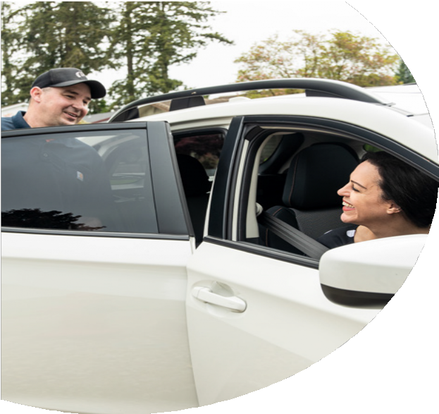

 

 

 

 

 

 

 

**Resources. Support.**

**Solutions.**

**For Get There Connect support and help getting started:**

 [**info@GetThereOregon.org**](mailto:info@GetThereOregon.org) **971-202-9758**