**Looking to energize + grow your workforce?**

Leverage low-cost commute + remote work solutions to serve your business needs using free tools & services!

55min



Daily average **commute**

**time** for U.S. workers.

*U.S. Census Bureau, 2019*

Today, work satisfaction plays a big role in employee morale, productivity, and retention that broadly impacts operational performance and the bottom line. Perceived work experience can also make or break a job candidate’s decision to join your team. Painful and exhausting commutes that drain pocketbooks can hurt both employee retention and talent recruitment.

Offering scalable, low-cost commute and remote work solutions to employees can serve many critical business needs. Leverage free resources, tools, and services from Get There Oregon and partners to improve employee commutes and help your workforce thrive and grow.

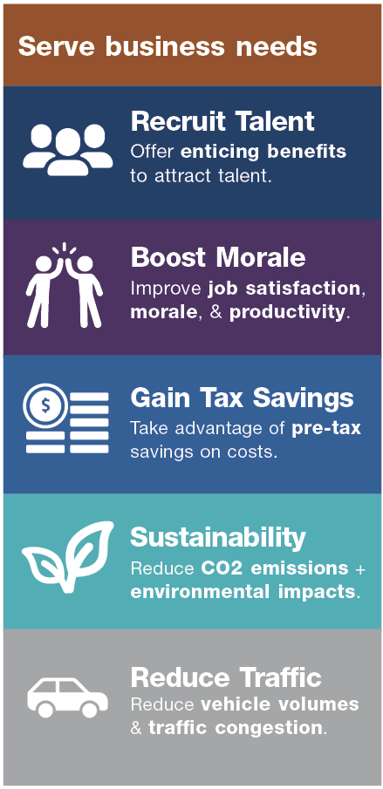

Employees who have

**quit** over bad commutes.

23%

*Robert Half, 2018*



**Employee commute and remote work support and benefits options**

**Why “the commute” matters**

Notwithstanding the COVID-19 crisis, employee commutes have steadily gotten longer over the last decade with traffic delays getting worse. Commute pain will continue to resurface with more employers welcoming employees back to worksites. Longer commutes don’t just cost employees time, but money and energy, too.

• **More workers commute from farther away** due to the lack of affordable housing.

• Commuters now **spend 20 more minutes a week—17 hours a year—commuting** than they did a decade ago.

• **Average commuting costs** were **up 34% to nearly $3,000** in 2022.

• A 2018 LinkedIn study found that **85% of workers would take a pay cut** to reduce their commute time.

And it’s not just employees who “pay” the cost of commuting. Bad commutes present a range of negative impacts on employers from lost employee productivity to hiring headwinds and costly employee turnover.

The good news in alleviating bad employee commutes is that there are a lot of options that come with all kinds of added benefits. Remote work that reduces commutes helps improve productivity and work-life balance. Employees sharing the ride to work by carpooling or vanpooling can also share the costs. Transit enables employees to save money and get time back they’d otherwise spend driving. Biking affords a host of health and wellness benefits.

There are many scalable, low-cost commute support and benefit options for employers to offer employees. The spectrum ranges from equipping employees with commute options and remote work information and tools to providing onsite amenities, perks, and benefits.

Assessing your employees’ commute needs and interests can help inform what support and benefits to offer. Get There Oregon and partners can provide consultation, identify resources and tools for employee use, and help with employee outreach and commute planning.

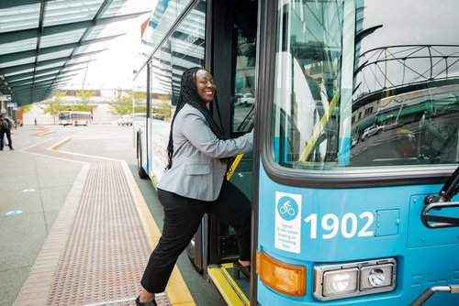

**Commute support & benefit options**

There are many scalable, low-cost commute support and benefit options to offer employees, including:

* Pre-tax benefits on qualifying transit and vanpooling costs
* Wellness credits to purchase bikes and gear
* Bikeshare and scooter share memberships
* Onsite amenities like bike parking and personal lockers
* Rewards for using commute options and working remotely
* Carpool, vanpool, transit, and bike commuting information, tips, and services
* Remote work arrangements to reduce employee commute trips
* Commute planning and carpool/ vanpool matching using Oregon’s free Get There Connect tool
* Transit information and passes
* No-cost employee vanpooling services
* Remote work resources, support tools, and tips

**Tips on getting started**

**“Meeting growing product demand requires expanding our workforce. We’re supporting commute options like carpooling to make employee commutes better and build a thriving and sustainable workforce.”**

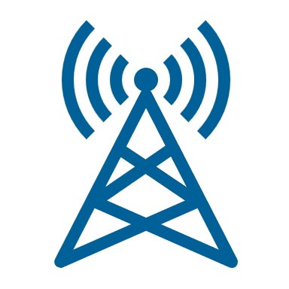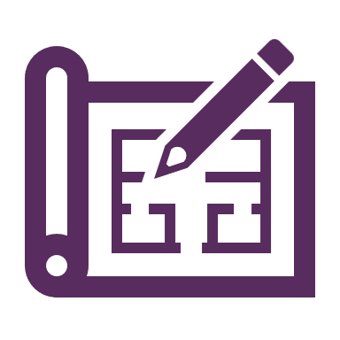

Learn about employee commutes and what commute options support, services, and benefits appeal most to them.

Promote commute options among your employees and connect them with resources, tools, and services. Get There and partners can provide employee materials and support.

Equip employees with resources and tools to explore and use commute options. Set up a customized employer network in Get There Connect to help with commute planning and ridematching.

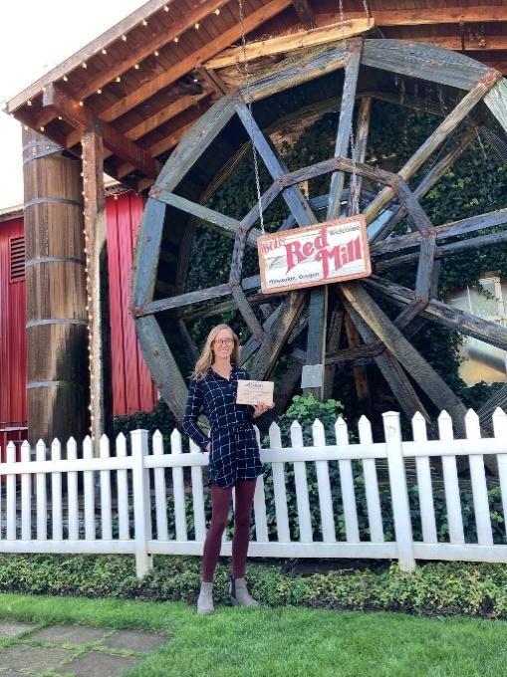

—Julia Person, Sustainability Manager, Bob’s Red Mill

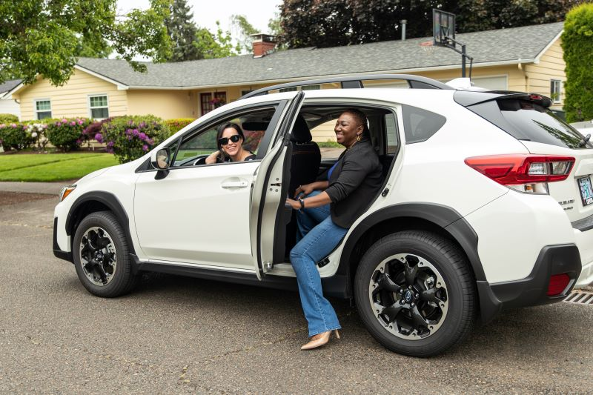

**Resources. Support. Solutions.**

Tap into Oregon’s free Get There Connect commute planning, ridematching, metrics, and rewards tool that offers employer networks for employees

Gain workforce insights + HR and operations strategies & employee program tips

Access employee programs, including challenges and rewards

**Visit GetThereOregon.org**