**Better Commutes**

**Vanpooling Solutions**

**Make getting to work a perk by tapping into employee vanpooling services**

**to make getting to work a perk**

Amid the many factors impacting organizational success is one pivotal cornerstone—your employees. Recruiting and retaining employees can be a challenge, and work satisfaction today plays a big role. That includes the commute, which for many onsite employees has become longer and more costly.

Bring your workforce a smarter way to commute with vanpooling. Vanpools let employees (typically 4-15) who live near each other and have longer commutes (about 20+ miles) share the ride to work and the costs. It’s a win-win that makes employee commutes better, serves as a retention and recruitment tool, and helps achieve other business goals.

Connect your employees with vanpooling services from Get There Oregon, local partners, and Commute with Enterprise—here’s how!

**VANPOOLING BENEFITS**

[](https://www.istockphoto.com/vector/people-line-icons-editable-stroke-pixel-perfect-gm1286348475-382883978?phrase=people%20icon)

**Retain & Recruit Talent**

Offering employees vanpooling support services is an enticing benefit and can help you diversify your talent pool by recruiting from farther away.



**Boost Work Experience & Morale**

Making employee commutes better improves job satisfaction and morale, while boosting productivity.



**Gain Pre-Tax Savings**

**SUPPORT SERVICES & TOOLS**

Employers and employees can take advantage of pre-tax savings on qualifying vanpool costs.

Tap into comprehensive employee vanpooling support services and tools at no cost to you!



Get support putting together a turnkey and cost-effective employee program from Get There, local partners, and Commute with Enterprise.

**Improve Sustainability**

Sharing rides reduces individual and organization CO2 emissions and environmental impacts.



Match employees into vanpools using Oregon’s free online tool Get There Connect and onsite matching support services provided by Commute with Enterprise (see reverse).



**Reduce Parking Needs**

Cutting back on the volume of vehicles at your facility reduces parking needs and congestion issues.

Connect employees with vehicle rental and maintenance, insurance, and roadside assistance from Commute with Enterprise (see reverse).

**For Get There Connect support:**

Info@GetThereOregon.org; 971-202-9758



Track and report real-time metrics, including vanpool participation, money saved, and reduced CO2 emissions using Get There Connect.

**Tap into Commute with Enterprise vanpooling services:**

David.C.Meigs@ehi.com; 541-778-1393

**COMMUTE WITH ENTERPRISE SERVICES**

Commute with Enterprise, a division of Enterprise Rent-A-Car that’s the largest vanpool provider in North America, provides a range of vanpool services at no or little cost to employers and their employees:

* Tailored turnkey and cost-effective employee program consultation and plan development.
* Employee vanpool matching, using cluster maps to identify vanpool partners and providing onsite matching support.
* Recent-model SUV, crossover, and van rental, in addition to employee onboarding.
* Full insurance coverage.
* 24/7 roadside maintenance.
* Real-time metrics reporting and quarterly impact reports.

**COMMON QUESTIONS**

**Are there vehicle rental options?**

**How much does vanpooling cost?**

Monthly vanpooling costs depend on the vehicle type, amenities, and commute distance. Everyone in the vanpool splits rental and fuel costs.

If someone drops out of a vanpool and a replacement can’t be found, then switching to a smaller vehicle can be explored.

Commute with Enterprise rents a wide selection of recent-model SUVs, crossovers, and vans that are low mileage and have optional amenities like WIFI.



**How is vehicle maintenance handled?**

**How is vehicle leasing set up? handeled?**

Vehicles from Commute with Enterprise are rented on a month-to-month basis.

Comprehensive maintenance and repairs are covered by Commute with Enterprise.



**What happens if riders drop out?**

**Who drives?**

Driving duties can be shared between vanpool partners. Drivers need to be 25 years of age or older and be licensed for a minimum of 5 years.

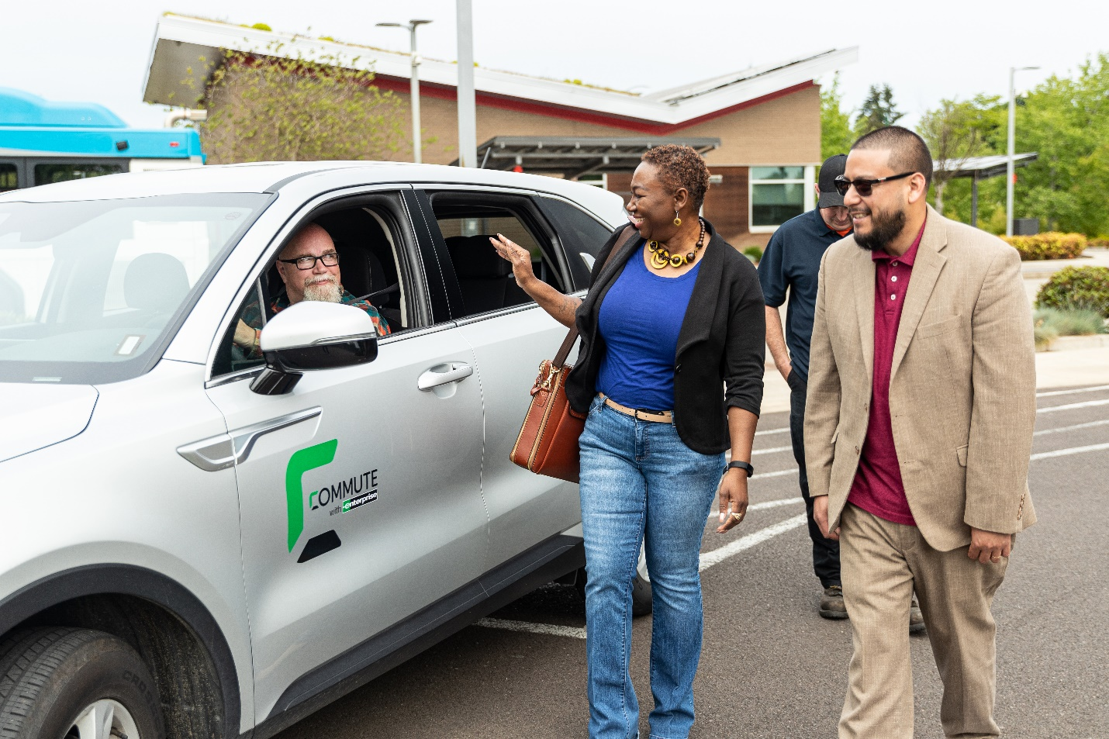

**Resources. Support. Solutions.**

Tap into Oregon’s free Get There Connect trip planning, ridematching, metrics, and rewards tool that offers employer networks for employees

Gain workforce insights, HR and operations strategies, and employee program tips

Access employee programs, including challenges and rewards

**Visit GetThereOregon.org**