[](https://www.istockphoto.com/photo/many-people-walking-in-the-city-center-in-vienna-gm1204988402-346931588)

**Workplace Wellness**

**Boost your employees’ health and wellness through active commuting support and benefits**

**and Active Commutes**

Today’s staffing issues make one thing clear: promoting and supporting your employees’ physical and mental health are more important than ever. Employers play a vital role in creating workplaces that foster employee wellbeing. Workplace wellness promoting healthy habits can improve employee health and job satisfaction, plus there are all kinds of benefits for employers, too.

Supporting active commute options at worksites—bicycling, walking, and taking transit—is a great scalable, relatively low-cost way for employers to boost employee health and wellness. Read on to learn about the many benefits of active commuting, and how to build support, benefits, and perks into your workplace wellness efforts.

**“Employee wellbeing has become more important than ever on many fronts, but especially so for retention and recruitment. Offering support and benefits for active commuting boosts both the physical and mental health of our employees among other benefits.”**

—Stacey Brown, Sr. Wellbeing Consultant, Providence Health & Services

**Active Commute Benefits**

**Among the many benefits active commuting offers…**

**“We’re building a culture at Keen that empowers employees to use active commute options through wellness perks, onsite amenities, and peer support, which also supports our workforce, performance, and environmental goals. “**

[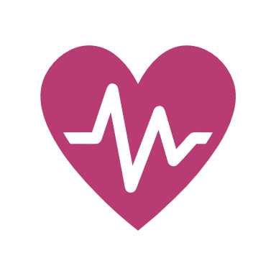

**Performance**

**Mental Health**

**Physical Health**

**Boosted Morale**

**Productivity**

[](https://www.istockphoto.com/vector/people-line-icons-editable-stroke-pixel-perfect-gm1286348475-382883978?phrase=people%20icon)[](https://www.istockphoto.com/vector/icons-related-with-success-motivation-willpower-leadership-determination-and-growth-gm933482978-255724506?phrase=morale%20icon)

**Retention & Recruitment**



—Sebastian Garcia, HR Workplace Assist., Keen Footwear

**Tips on getting started…**

Here are some strategies to start building active commuting support, benefits, and perks into your wellness efforts:

* Ask employees about what types of active commuting support, services, and benefits appeal most to them
* Factor in organizational needs like improving facilities and amenities and reducing employee burnout
* Tap into local resources and programs—like bike safety and maintenance workshops and Oregon’s trip planning and rewards tool Get There Connect that’s available for free to all Oregonians
* Be flexible and make adjustments based on your employees’ needs

**Support, Services, & Benefits Options**

**There are all kinds of active commuting support, services, and benefits to offer employees, including:**

**“Popularity in bike commuting and walking to work continues to grow as our commuter surveys and national studies show. More employees today are choosing healthier active commute options than ever before.”**

* Wellness credits for purchasing equipment and gear
* Monthly financial rewards for logging active commute trips
* Onsite tools like bike pumps and multitools for repairs and maintenance
* Amenities, ranging from secure bike parking to personal lockers and/or shower facilities
* Bike tune-up days
* How-to Information about active commuting and available onsite amenities
* Peer support and tips to help employees start active commuting
* Active commuting information and resources in new employee packets

—Nick Gross, Sr. Active Transportation Planner, Kittelson & Assoc.

](https://stock.adobe.com/search/images?filters%5Bcontent_type%3Aimage%5D=1&filters%5Bcontent_type%3Aphoto%5D=1&native_visual_search=637277379ca13&search_type=visual-search-browse&asset_id=119098770)

**Resources. Support. Solutions.**

Tap into Oregon’s free Get There Connect trip planning, ridematching, metrics, and rewards tool that offers employer networks for employees

Gain workforce insights + HR and operations strategies & employee program tips

Access employee programs, including challenges and rewards

**Visit GetThereOregon.org**